All Karat Questions-Anwers
Theroticals=
1) 1) what is the advantage and disadvantage of checked exception?

Checked Exception-This exception that are checked at compile time.
A checked exception is an exception that the Java compiler forces us to handle.
{ Note- checked exception are checked by the compiler but thrown at runtime}

We can handle by
1) Catch it using try-catch, or
2) Declare it using throws in the method signature.

Common Checked Exceptions
- IOException
- SQLException
- ClassNotFoundException
- FileNotFoundException
- InterruptedException
- what is the advantage and disadvantage of checked exception?
Ans=Advantages
- Compile-Time Safety-
FileReader reader = new FileReader("file.txt"); // Compiler forces handling {when we write this line we have to handle with try or throw}

2)Force to handle the error
3)Improve the understanding
4)Make code safer (reduce the sudden program crash)
5) help us find errors early at compile time.

Disadvantages
- Make code longer,
- Code becomes harder to read and understand.
- They require extra try-catch blocks, which can confuse beginners
- Reduce readbility

{simple checked exception=More safety but more code}
++++++++++++++++++++++++++++++++++++++++++++++++++++++++++++++
- what is the advantage of upper bound and lower bound (<? extends Animal>, <? super Animal>)?
- What is the purpose of using bounded wildcards in Java Generics?

Ans=
Bounded wildcards are used to make generic code more flexible while keeping type safety.
They allow a method to accept a range of related types, instead of only one specific type.
✅ Why are bounded wildcards needed?
Because Java generics are invariant.
That means:
Java
List<Integer> is NOT a subtype of List<Number>
Show more lines
Even though Integer is a subclass of Number.
👉 Bounded wildcards solve this limitation.

-------
✅ Types of bounded wildcards
In Java Generics, upper bound and lower bound (<? extends Animal> and <? super Animal>) are used to make your code more flexible and type-safe when working with collections.
Upper Bound-use extends-reading-list.get(0)-safe
lower bound-use super-writing-list.add(10)-safe
Upper bound-(<? extends Animal>,but taking example (<? extends Number>
Example-List<? Extends Number> list;>
The list can contain Number or sub classes(Integer, Double etc.)
Advantages-
1)More flexibility (You can pass List<Integer>,List<Double> etc)
2)Type safety (You are sure element are at least of type Number)
3)Good reading for data
{Note- But you cannot add element (except null) }
Lower bound
Example-List<? Super Integer> list;>
The list can contains Integer or Parent classes (Number, Object etc.)
Advantages-
1)Safe for adding data
2)Useful for writing data
3)Flexible for parent types
{Note- but when reading, you only get Object}

++++++++++++++++++++++++++++++++++++++++++++++++++++++++++++++++
- Can a Map key mutable? why or why not?
Yes, a Map key can be mutable in Java, because Java does not restrict it.
But in practice, a Map key should NOT be mutable (or it must never change after insertion).
{ In Java, a Map key can be mutable, but it should be immutable.
Because maps (especially HashMap) use the key’s hashCode() to decide where to store the entry and equals() to find it later.
If the key is mutable and we change the fields that affect hashCode()/equals() after inserting it, the hash changes and the entry stays in the old bucket, so get() can return null even though the entry exists.
Therefore, keys should be immutable (like String, Integer) or at least not modified after putting into the map.
}
✅ Why NOT? (Main reason)
Most Map implementations use the key to store and later locate the value:
1) In HashMap
HashMap uses:
- hashCode() → to decide which bucket to store the entry in
- equals() → to find the correct key within that bucket
✅ If the key is mutable and its fields change after put(), then:
- the key’s hashCode() may change
- the entry stays in the old bucket
- but get() searches in a different bucket (based on new hash)
👉 Result: get(key) may return null even though the entry is still inside the map.
Interview line:
“A mutable key can become logically unreachable if its hashCode/equals changes after insertion.”

2) In TreeMap
TreeMap uses:
- compareTo() or Comparator → to keep keys in sorted order
✅ If the key changes after insertion and it affects comparison:
- the key may be in the wrong position in the tree
- lookups and ordering can break
Interview line:
“In TreeMap, mutable keys can break the ordering, causing incorrect retrieval or inconsistent sorting.”

✅ Short Example (to impress interviewer)
“If I use a custom object as a key and change the field used in hashCode() after inserting it into a HashMap, map.get(key) can fail because the bucket location is based on the old hash.”

Immutable map returned by Map. of() or Map. ofEntries()-so immutable maps do not allow adding entries, updating values, removing entries.
++++++++++++++++++++++++++++++++++++++++++++++++++++++++++++++
- Contract between equals() and hashCode() methods
[ if two objects are considered equal using equals method then they must return like same hash code. But if the two objects is having same hash code then necessarily they may not be equal.
example like hash map or has set, so hashmap or hashset .uses this hash code to determine the bucket and then uses the equals to compare the objects within the bucket So whenever there is a hash.
It uses the hash code to find the appropriate bucket into which the key falls into and then find the and then compare the objects using the equals method. So and we also need to override equals method and also the hash code method within the class.

If we override only equals, but if we don't override the hash code method, then two logical equal objects may end up in different buckets and the map may fail to retrieve them correctly.
So that's why whenever we override equal, we must also override hash code method to maintain the contract between them. So again the contract between equals and hash code is very important while while working with the collections like hash map or has set. ]

Ans- In Java, equals() and hashCode() must work together to correctly identify objects—especially in hash-based collections like HashMap, HashSet, and Hashtable.

In Java, the contract says if two objects are equal according to equals(), they must return the same hashCode().
The reverse is not required because collisions can happen. Hash-based collections like HashMap and HashSet use hashCode() to find the bucket and then equals() to match the key. So if we override equals() but not hashCode(), map/set behavior breaks—like failing retrieval or storing duplicates. That’s why whenever we override equals(), we must override hashCode() using the same fields.

✅ Rule 1: If two objects are equal, they must have the same hash code
If a.equals(b) is true, then a.hashCode() == b.hashCode() must be true.

✅ Rule 2: If two objects have the same hash code, they may or may not be equal
If a.hashCode() == b.hashCode(), a.equals(b) can be true or false.
This is called a hash collision. Collisions are allowed.

✅ Rule 3: hashCode() should be consistent during an object's lifetime (if fields don’t change)
If the object’s fields used in equals()/hashCode() don’t change, then repeated calls to hashCode() should return the same value.

✅ Rule 4: equals() should be consistent
If nothing changes in the objects, repeated calls to equals() should return the same result.

++++++++++++++++++++++++++++++++++++++++++++++++++++++++++++++++
5.what is expected final keyword?
final in Java is a non-access modifier used to apply restrictions.
Depending on where you use it (variable / method / class), it means you cannot change / override / extend.
Interview one-liner:
“final is used to make variables constant, prevent method overriding, and stop inheritance.”
In Java, final is used to apply restriction. A final variable cannot be reassigned, a final method cannot be overridden, and a final class cannot be inherited. It is widely used for constants (static final) and to support immutability. Also, in Java 8+, variables used in lambdas must be final or effectively final
final can be used with:
- Variable → cannot reassign
- Method → cannot override
- Class → cannot extend

Expected final -A local variable is not declared with final, but its value is assigned only once and never changed (reassigned) after that.
Java requires variables used inside lambda expressions or anonymous classes to be final or effectively final.
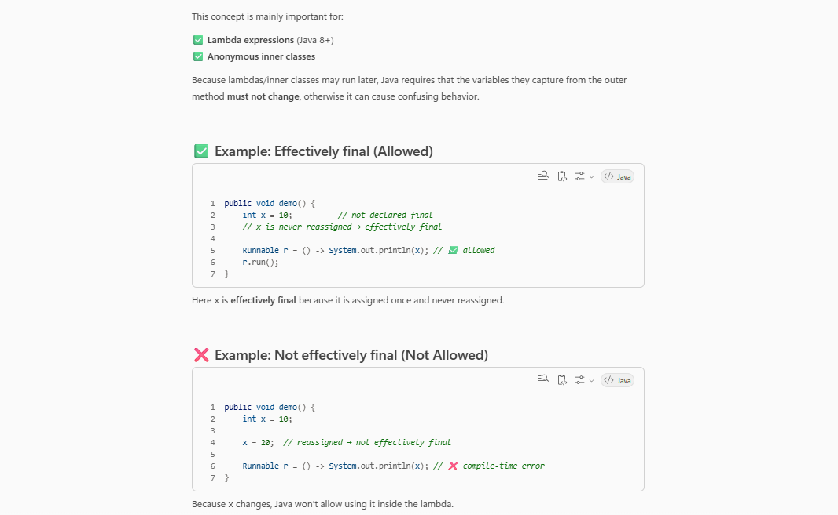
++++++++++++++++++++++++++++++++++++++++++++++++++++++++++++++++++++++

+++++++++++++++++++++++++++++++++++++++++++++++++++++++++

6)how object is moving one generation to another generation in heap
[ when does a Java object get promoted to a different heap generation.
memory is divided into different heap generations. So there is, I mean new objects are first allocated in the Eden space in the inside the Young generation. So when a minor garbage collection occurs, objects that survive are moved to survivor spaces. So each time an object survives a garbage collection cycle, its age increases. So if the object survives.Beyond a certain threshold, it gets promoted to the old generation
And then major garbage collection happens in the old generation and is typically more expensive.
So like the top most hierarchy is actually the old generation or the tenure space. What that means is like if an object is created, if a specific object is created and if it is surviving more number of garbage collection cycles, then it keeps getting promoted into the old generation. So I think the number of cycles is equal to the age of the object.
If it survives more, it keeps getting promoted to old space. Now the other part is called the N generation. So whenever a new object is created, it is actually the part of the Eden space. So Eden space is like we can call it as like minor garbage collection.
So even after Eden space there are something called Survivor space where if the object is created they can get promoted to the individual survivor space depending upon the number of garbage collection cycles that they have survived. So and out of that we have also another space which is actually to store the class metadata which is called metas Space.
]
Ans-Objects are created in the Young Generation, and if they survive garbage collection, they are moved to the Old Generation
Created → Young Generation → Old Generation
- When an object is created, it is placed in the Young Generation (Eden space).
- When memory gets full, Garbage Collection (GC) runs.
- If the object is still being used, it moves to the Survivor space.
- If the object survives many GC cycles, it is moved to the Old Generation.
- Objects that are not used anymore are deleted by GC.
Memory management in Java is mostly handled automatically by the JVM (Garbage Collector), but as a developer you still need to write code that allows GC to work efficiently and avoid memory leaks.
1) Who manages memory in Java?
✅ JVM manages memory automatically
- Java allocates objects in Heap
- JVM frees unused objects using Garbage Collection (GC)
- You don’t manually free memory like in C/C++
Interview line:
“Java memory management is automatic via JVM allocation and garbage collection, but developers must avoid holding unnecessary references.”

2) Java memory areas (important for interviews)
✅ Stack Memory
- Stores method calls, local variables, references
- Memory is freed automatically when method ends
- Fast and thread-specific
✅ Heap Memory
- Stores objects and class instances
- Shared across threads
- Cleaned by Garbage Collector
✅ Metaspace (Java 8+)
- Stores class metadata (replaced PermGen)
- Can grow until limited by JVM options
Simple summary:
- Stack → local variables, calls
- Heap → objects
- Metaspace → class metadata

3) How Garbage Collection works (simple)
✅ Key idea
GC removes objects that are no longer reachable.
An object becomes eligible for GC when:
- No active reference points to it
Typical GC (Generational concept)
Heap is divided into:
- Young Generation (Eden + Survivor spaces) → many short-lived objects
- Old Generation → long-lived objects
Objects move: Eden → Survivor → Old (if they survive multiple GCs)
++++++++++++++++++++++++++++++++++++++++++++++++++++++++++++++++++
7)Dependency Injection concept & Management of code with DI-
[ it's a design pattern where a class does not create its own dependencies, but instead it receives them from an external source like a framework or container.
So the main advantage is that, It reduces the tight coupling. If a class directly instantiates its dependencies using new keyword, it becomes tightly coupled to those implementations. So with the dependency injection, we can depend on abstractions instead of concrete classes. So in large systems this helps managing complexity because components become modular and. Easier to replace.
for example we can inject a mock implementation during unit testing which improves the testability. So it is based on like the principle of inversion of control where the control of object creation is shifted from the application or the class to a container.Such as like the Spring framework.
so overall like dependency injection improves flexibility, maintainability or testability of the code in large applications. ]

Dependency Injection means Spring provides the required objects (dependencies) to a class, instead of the class creating them itself.
In short:
Spring creates and manages objects and injects them where needed.

Why Dependency Injection is Important in Spring Boot
Spring Boot is built around DI and Inversion of Control (IoC). DI helps Spring Boot applications become:
- Loosely coupled
- Easy to maintain
- Easy to test
- Easy to extend

How DI Works in Spring Boot
1. Spring Creates Objects (Beans)
Spring Boot creates objects called beans using annotations like:
- @Component
- @Service
- @Repository
- @Controller
Java
@Service
public class PaymentService {
}
Show more lines

2. Spring Injects Dependencies Automatically
Java
@RestController
public class OrderController {

private final PaymentService paymentService;

public OrderController(PaymentService paymentService) {
this.paymentService = paymentService; // injected by Spring
}
}
Show more lines
✅ You do not create objects using new
✅ Spring injects them automatically

How DI is Useful in Spring Boot
1. Loose Coupling
- Classes depend on interfaces, not implementations
- Easy to replace logic without changing code
Example:
Java
interface Payment {
void pay();
}
Show more lines
You can switch implementations without changing controller code.

2. Easy Testing
- You can inject mock objects in tests
- No need to load real databases or services
✅ Makes unit testing simple and fast

3. Better Code Management
- Object creation is handled by Spring
- Business logic stays clean
- Code is easier to read and maintain

4. Easy Configuration and Scalability
- Change behavior using configuration
- Add new features without modifying existing code

5. Lifecycle Management
Spring Boot:
- Creates objects
- Injects dependencies
- Manages object lifecycle
- Destroys objects when not needed

Types of Dependency Injection in Spring Boot
- Constructor Injection ✅ (recommended)
- Setter Injection
- Field Injection (@Autowired)
👉 Constructor injection is best because it:
- Makes code immutable
- Is easier to test
- Avoids null issues

Simple One-Line Interview Answer
“Dependency Injection in Spring Boot allows Spring to create and manage objects and inject dependencies automatically, making the application loosely coupled, testable, and easy to maintain.”
What Is the IOC in spring boot feamework.
Ans-
Spring IoC is a core concept of the Spring Framework where Spring takes control of creating, managing, and injecting objects (beans) instead of the developer doing it manually.
👉 In simple words:
Spring controls object creation and dependency management.

What is IoC Container in Spring?
The IoC Container is the heart of Spring. It:
- Creates objects (beans)
- Manages their lifecycle
- Injects dependencies
- Destroys objects when needed
Common IoC Containers:
- ApplicationContext ✅ (most used in Spring Boot)
- BeanFactory
++++++++++++++++++++++++++++++++++++++++++++++++++++++++++++++
how do you make a class more testable?
[ first thing I will focus on is like reducing tight coupling. So a class should depend on abstractions rather than the concrete implementations so that the dependencies can be more during testing. So using dependency injection helps here because we can inject mock implementations instead of real services like databases or external APIs.
So another thing was like a class should be having a single responsibility, should follow a single responsibility principle.And then one class should be responsible for its own use case and then it should be open for extinction and close for modification.
So whenever we try to remove any of the replace any of the methods, it should not affect the existing functionality. That's how it should work.
And another important factor is like minimizing side effects.
So methods that modify global state or write to files or any methods that are called that are making network calls we can. It is harder to test them, so it's better to separate the business logic from the external interactions. and also keeping methods small focused also improves testability.
So it if a class follows single responsibility and becomes easier to test individual behaviors and also it is better to maintain pure functions where output depends only on input. In that way it will be easier to test.

++++++++++++++++++++++++++++++++++++++++++++++++++++++++++++++++
Because Java’s equals() contract says:
- Any non-null object compared to null should return false.
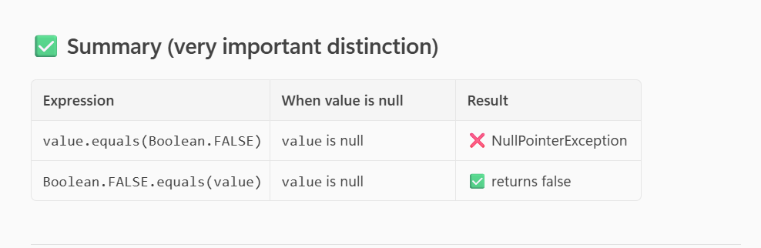

public Boolean isCondition(Boolean value){
if(!value.equals(Boolean.false)){
return true;
}else{
return false; } }
Your method has two issues:
- Boolean.false ❌ (does not exist → compile error)
- value.equals(...) when value is null → NullPointerException at runtime
This is not a valid Boolean constant in Java.
The constants are:
- Boolean.FALSE
- Boolean.TRUE
✅ What does your function actually do?
Your logic is equivalent to:
- return true if value is true
- return false if value is false
- crash if value is null

So the correct intended version depends on what you want when value is null:
Option A: Treat null as false (most common)
Javapublic boolean isCondition(Boolean value) {
return Boolean.TRUE.equals(value);}
+++++++++++++++++++++++++++++++++++++++++++++++++++++++++++++++++
How do you optimize a Java application?
Answer:
Optimizing a Java application requires a multi-layered approach, focusing on code efficiency, JVM tuning, and external systems like databases. I always follow a measure-first, optimize-later strategy.

1. Code-Level Optimization
First, I identify bottlenecks instead of guessing.
- I use profiling tools like VisualVM, JProfiler, or YourKit to analyze CPU usage, memory consumption, and slow methods.
- I reduce object creation, especially inside loops, to lower garbage collection overhead.
- For string concatenation in loops, I use StringBuilder instead of String to avoid creating multiple immutable objects.
- I prefer primitive data types (int, double) over wrapper classes (Integer, Double) wherever possible to reduce heap usage.
- I choose the right collection based on use case—ArrayList for fast access, HashMap for lookups—and pre-size them to avoid resizing.
- For concurrency, I use java.util.concurrent utilities like ExecutorService, ConcurrentHashMap, and atomic classes instead of manual synchronized blocks to reduce lock contention.

2. JVM and Memory Optimization
After code optimization, I focus on JVM tuning.
- I set fixed heap sizes using -Xms and -Xmx to avoid runtime heap resizing.
- I choose an appropriate Garbage Collector, usually G1GC for most applications, or ZGC for low-latency requirements.
- I allow proper JVM warm-up so the JIT compiler can optimize hot code paths.
- In containerized environments like Docker or Kubernetes, I ensure the JVM is container-aware (Java 11+ or Java 8u191+) so it respects CPU and memory limits.

3. Database and External Optimization
Most performance issues come from external systems, especially databases.
- I use connection pooling (for example, HikariCP) to reuse database connections instead of creating new ones.
- I optimize SQL queries using PreparedStatements, proper indexes, and by avoiding SELECT * and N+1 queries.
- I implement caching using tools like Caffeine or Redis for frequently accessed and rarely changing data.
- For file and network I/O, I use buffered streams and batch operations to reduce system calls.

Conclusion
In summary, I optimize Java applications by:
- Measuring performance first
- Fixing code-level inefficiencies
- Tuning JVM and GC only when needed
- Optimizing database and external calls
This approach ensures better performance, scalability, and stability without premature optimization.

✅ One-line version (if interviewer asks briefly):
“I profile first to find bottlenecks, optimize code to reduce object creation and contention, tune JVM and GC based on metrics, and improve database performance using pooling, query optimization, and caching.”

